Live Meeting Intranet Portal Administrator’s and Programmer’s Guide

February 2005



The information contained in this document represents the current view of Microsoft Corporation on the issues discussed as of the date of publication. Because Microsoft must respond to changing market conditions, it should not be interpreted to be a commitment on the part of Microsoft, and Microsoft cannot guarantee the accuracy of any information presented after the date of publication.
This document is for informational purposes only. MICROSOFT MAKES NO WARRANTIES, EXPRESS, IMPLIED OR STATUTORY, AS TO THE INFORMATION IN THIS DOCUMENT.
Complying with all applicable copyright laws is the responsibility of the user. Without limiting the rights under copyright, no part of this document may be reproduced, stored in or introduced into a retrieval system, or transmitted in any form or by any means (electronic, mechanical, photocopying, recording, or otherwise), or for any purpose, without the express written permission of Microsoft Corporation.
Microsoft may have patents, patent applications, trademarks, copyrights, or other intellectual property rights covering subject matter in this document. Except as expressly provided in any written license agreement from Microsoft, the furnishing of this document does not give you any license to these patents, trademarks, copyrights, or other intellectual property.
Unless otherwise noted, the example companies, organizations, products, domain names, e-mail addresses, logos, people, places, and events depicted herein are fictitious, and no association with any real company, organization, product, domain name, email address, logo, person, place, or event is intended or should be inferred.
© 2005 Microsoft Corporation. All rights reserved.
Microsoft, Active Directory, Outlook, Visual Studio, Windows, and Windows Server are either registered trademarks or trademarks of Microsoft Corporation in the United States and/or other countries.
The names of actual companies and products mentioned herein may be the trademarks of their respective owners.

Contents
Introduction 1
What Is the Live Meeting Intranet Portal? 1
Why Use the Portal? 1
How does the Portal Work? 3
Keyboard Shortcuts for Common Portal Tasks 10
Administrator’s Guide 11
Planning the Installation 11
Upgrading from Version 1 of the SSO Portal 12
Installing the Portal 12
Installing an Additional Instance of the Portal 14
Configuring the Portal 15
Making Portal User Names Conform to Common Naming Conventions 28
Editing the Portal Configuration File 28
Managing the Portal 29
Maintaining Performance Counters 33
Uninstalling the Portal 34
Programmer’s Guide 36
Web Method Call Outcomes 38
ActivateAccount 39
ChangePassword 40
CreateAccount 42
DeactivateAccount 45
DeleteAccount 46
GetAccountStatus 48
GetTicket 50
Customizing the Portal Web Pages 51
Appendix: Troubleshooting Portal Installation 53

Introduction

What Is the Live Meeting Intranet Portal?
Figure 1 The Live Meeting Intranet Portal architecture
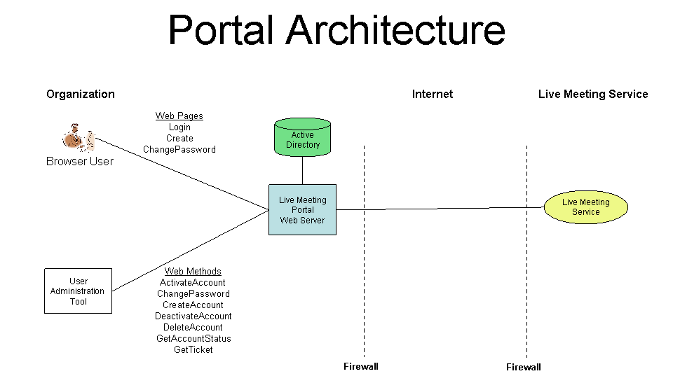
The Microsoft® Office Live Meeting Intranet Portal (“the Portal”) is a Microsoft Internet Information Services (IIS) Web application that uses ASP.NET. The Portal is installed on a Microsoft Windows® Web server. The Portal communicates with the Live Meeting service through XML (Extensible Markup Language) API (application programming interface) calls sent across the Internet.
Users can access the Portal Web pages from Web browsers to:
- Create a new Live Meeting account.
- Log in to the Live Meeting service.
- Change the password for the Live Meeting account.
- Allow users to access rich content related to Live Meeting.
Programs or scripts that call the Portal Web methods can automate Live Meeting account management. Use the Web methods to:
- Create or delete a Live Meeting account.
- Activate or deactivate a Live Meeting account.
- Change the password for a Live Meeting account.
- Get the status of a Live Meeting account.

Why Use the Portal?
The Portal makes it easier to deploy and manage Live Meeting. Use the Portal to:
- Automatically create Live Meeting accounts for users. When a user browses to the Portal Create page, the Portal:
- Authenticates the user through Windows authentication.
- Retrieves the user’s attributes from Active Directory® directory service.
- Determines if the user has a Live Meeting account by contacting the Live Meeting service.
- If the user does not have an account, but is entitled to one, the Portal creates the account for the user.
The administrator controls the type of account created, if any, through Portal configuration options and Active Directory group memberships.
- Allow authenticated Windows users to log in to Live Meeting without entering a Live Meeting user ID and password. When a user browses to the Portal Login page, the Portal:
- Authenticates the user through Windows authentication.
- Retrieves the user’s attributes from Active Directory.
- Determines if the user has a Live Meeting account by contacting the Live Meeting service.
- Automatically logs the user in to Live Meeting.
If the user does not have a Live Meeting account, the Portal invites the user to create one. When users log in to Live Meeting through the Portal, they don’t enter and do not know their Live Meeting password. The Portal eliminates the need for the administrator to issue and manage Live Meeting user IDs and passwords.
- Reveal the Live Meeting password to users when they create their Live Meeting account, provided the administrator has enabled this feature. This permits users to log in to the Live Meeting service directly without going through the Portal.
- Allow users to change or reset their Live Meeting passwords. Administrators can set rules for passwords using Live Meeting.
- Ensure that deactivated Windows users do not log in to Live Meeting. Do this by requiring users to log in through the Portal and by not revealing Live Meeting passwords to them. The Portal ensures that only users with active Windows accounts can log in to Live Meeting.
- Automatically synchronize a user’s Live Meeting account settings with the user’s Active Directory settings each time the user logs on through the Portal. For example, by changing a user’s Active Directory group membership, a Live Meeting organizer can be promoted to an administrator or demoted to a member.
- Automate Live Meeting account management by writing programs or scripts that use the Portal Web methods. For example, use the CreateAccount Web method whenever a new user joins the organization. Similarly, use the DeactiveAccount Web method whenever a user leaves the organization.

How does the Portal Work?
This section provides background information about how the Portal works and highlights the sequences for:
- Creating an account
- Logging in
- Logging in through an external portal
- Joining an ACL-protected meeting
- Changing a password
- Deactivating and deleting an account

Creating an Account
This section describes how a user can create a new Live Meeting account by browsing to the Portal Create Web page.
Figure 2 Creating an account sequence
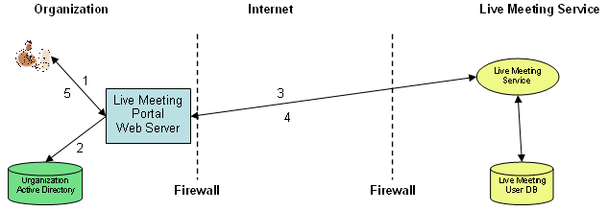
- The user clicks the Portal Create URL (Uniform Resource Locator) in Internet Explorer. Internet Explorer opens the Create page and includes the user’s Windows identity when making the IIS Web Server request. IIS authenticates the user through Windows integrated authentication. If the user cannot be authenticated, the Portal reports the error to the user and does not proceed.
- The Portal retrieves the user’s Windows domain name and user ID from IIS, and the user’s attributes from Active Directory. It determines whether the user is entitled to use Live Meeting based upon the user’s Active Directory group membership. If the user is not a member of an Active Directory group that entitles the user to use Live Meeting, the Portal redirects the user to the Portal Denied Web page. The Denied Web page explains why access to Live Meeting was not granted.
- The Portal does the following for entitled users:
- It calls the Live Meeting service GetUser XML API to determine if the user has a Live Meeting account. This API looks for an authenticated user’s e-mail ID in Active Directory and matches it to a Live Meeting account with the same e-mail ID. This and all subsequent XML API calls between the Portal and the Live Meeting service use SSL (Secure Sockets Layer). All XML API calls are performed under the identity of a Live Meeting administrator account specified by the Portal administrator when the Portal was configured.
- If the user has a Live Meeting account, the Portal redirects the user to the Portal’s Welcome Web page.
- The Portal determines the user’s Live Meeting user ID based upon the user’s Active Directory attributes and the Live Meeting account naming policy specified by the Portal administrator. Account naming policies are described in more detail in “Userid” later in this section.
- The Portal determines the user’s Live Meeting role based upon the user’s Active Directory group memberships.
- The Portal calls the Live Meeting service CreateUser XML API, passing the Live Meeting user identity, role, password, and other Live Meeting account attributes.
- The Live Meeting service creates a new Live Meeting account for the user and returns an XML response indicating that the account was successfully created.
- If the Password Display check box is selected, the Portal displays the Live Meeting password to the user. The Portal then redirects the user to the Portal Welcome page that is tailored to the user’s role. A Welcome Administrator page appears for new administrators, a Welcome Organizer page appears for new organizers, and a Welcome Member page is appears new members. Welcome pages are simple HTML Web pages. Customize the Welcome pages to display information suited to the needs of the organization. For example, the Welcome page might contain information about Live Meeting training and support that the organization provides.
When the Portal creates a new Live Meeting account, it specifies the following attributes for the account:
The Portal determines the Live Meeting user ID based upon the AccountNamingPolicy specified when the Portal was configured.

Userid
If AccountNamingPolicy=EmailFullname, the Live Meeting user ID is taken from the Active Directory mail attribute. For example, Bill@contoso.com becomes Live Meeting user: Bill@contoso.com. The e-mail attribute was chosen as the default Live Meeting user ID because e-mail names are unique, easily remembered, and rarely change. It is also in keeping with the move to User Principal Names for Windows logon that began in Microsoft Windows 2000.
If AccountNamingPolicy=EmailNickname the Live Meeting user ID is taken from the first part of the Active Directory mail attribute. For example, Bill@contoso.com becomes Live Meeting user: Bill.
If AccountNamingPolicy= LogonUsername the Live Meeting user ID is taken from the user’s Windows logon name. For example, Windows user contoso\Susan becomes Live Meeting user: Susan.
We strongly recommend that you use EmailFullname because it results in Live Meeting account identities that are unique and well known. All other options are provided for backward compatibility. If you have manually issued Live Meeting accounts that do not conform to the AccountNamingPolicy, please see the “Administrator’s Guide” later in this document.
The Live Meeting username attribute is taken from the Active Directory displayName attribute.

Username
The Portal generates a unique, cryptographically strong, Live Meeting password for each Live Meeting user. This password is only revealed to the user if the Portal administrator clicks the Password Display check box when configuring the Portal.

Password
If users always log in to Live Meeting through the Portal, they do not need to know their Live Meeting password. Hiding the password from the user has three advantages:
- The user does not need to remember the password.
- The passwords can be longer and stronger.
- Once the user is deactivated in Active Directory, the user can no longer log in to Live Meeting.
Live Meeting conference centers determine the password policies for all of the portals they manage. The Portal administrator does not set password policy for a portal. Password policy is passed from the Live Meeting conference center to the Portal using an XML API. Portal users get passwords from the conference center that conform to the conference center password policy.

Logging in
This section describes how a user can log in to Live Meeting by browsing to the Portal Login Web page located inside the firewall.
Figure 3 The Log in sequence
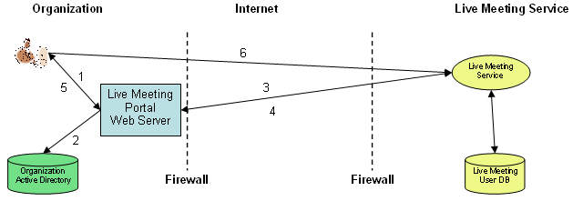

- The user clicks the Portal Login URL in Internet Explorer. Internet Explorer opens the Portal Login page and includes the user’s Windows identity when making the Internet Information Services (IIS) Web Server request. IIS authenticates the user through Windows integrated authentication. If the user cannot be authenticated, the Portal reports the error to the user and does not proceed.
- The Portal retrieves the user’s Windows domain name and user ID from IIS, and the user’s attributes from Active Directory. It determines whether the user is entitled to use Live Meeting based upon the user’s Active Directory group membership. If the user is not a member of an Active Directory group that entitles the user to use Live Meeting, the Portal redirects the user to the Portal Denied Web page. The Denied Web page explains why the user was not granted access to Live Meeting. To help the user, you should customize the contents of the Denied Web page explaining why access was denied.
- The Portal does the following for entitled users:
- It calls the Live Meeting service GetUser XML API to determine if the user has a Live Meeting account. This API looks for an authenticated user’s e-mail ID in Active Directory and matches it to a Live Meeting account with the same e-mail ID. This and all subsequent XML API calls between the Portal and the Live Meeting service are performed using SSL. All XML API calls are performed under the identity of a Live Meeting administrator account specified by the Portal administrator when the Portal was configured.
- If the user does not have a Live Meeting account, the Portal redirects the user to the Portal’s Create Live Meeting Account Web page and invites the user to create an account.
- If the user has a Live Meeting account, but the Live Meeting account settings do not match the user’s current Active Directory settings, the Portal calls the Live Meeting service UpdateUser XML API to update the user’s Live Meeting role or user name. For example, a user who was formerly a member of the Live Meeting organizers group might now be member of either the administrators or members Active Directory group. The Portal automatically promotes the user to be a Live Meeting administrator or demotes the user to be a Live Meeting member, as appropriate. The Portal administrator can disable automatic account update by clearing the Account Update check box when configuring the Portal.
- The Portal calls the Live Meeting service CreateTicket XML API and passes the Live Meeting identity of the user and the ticket timeout interval, which can be up to 300 seconds. The Portal administrator can override the default Ticket Timeout interval when configuring the Portal.
- The Live Meeting service returns a one-time login Ticket URL containing a 16 character login ticket number in the HTTP query string such as: http://www3.livemeeting.com/cc/contoso?ticket=s5dzqwvsvxv7d3jp
- The Portal returns the Ticket URL as a 302 error (redirect response) to Internet Explorer.
- The Ticket URL redirects Internet Explorer to the Live Meeting service with the login ticket in the query string. The Live Meeting service verifies the login ticket, logs the user in to the Live Meeting service, and displays the user’s Live Meeting home page. Once the user is authenticated through the login ticket, it is exactly as if the user had entered the Live Meeting user ID and password manually. The user can continue using the service until the browser session expires.
The Login page is mostly transparent to the user. When the user clicks the Portal Login page URL, the page is automatically redirected to the Live Meeting service. The Login page only displays information to the user if an error occurs.

Logging in through an external portal
This section outlines how to provide an external Portal for users located outside the firewall. An external Portal is a Portal Web application that is accessible from the Internet.
Figure 4 Logging on through an external portal sequence
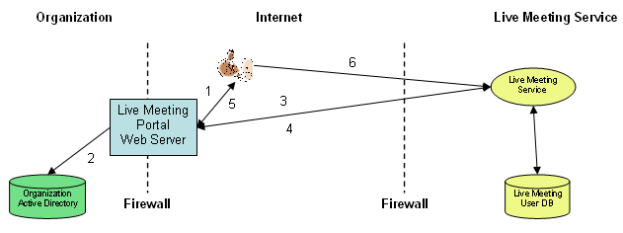
The experience of browser users inside and outside the firewall is the same. External Portals are normally installed in your organization’s perimeter network (also known as DMZ, demilitarized zone, and screened subnet). A browser user located outside the firewall connects to Live Meeting by clicking the External Portal URL. The Portal prompts the user for the Windows credentials using IIS Basic authentication over SSL. The user is logged on to Windows using these credentials. Live Meeting log in then proceeds as described for intranet login.
Alternatively, allow users located outside of the firewall to connect to the internal Portal through a VPN (virtual private network).

Joining an ACL-Protected Meeting
The organizer of an ACL- (access control list-) protected meeting usually sends a meeting invitation to each attendee through e-mail. The meeting invitation is generated by the Live Meeting service. A typical invitation looks like the following:
You have been invited to attend a Microsoft Office Live Meeting.

At the time of the meeting, click on the following link to attend.
URL: http://www.livemeeting.com/cc/contoso/join?id=5833HF&role=attend

Subject: Joining ACL Protected Meetings

When: Thursday, Dec 11, 2003 8:00 PM (PST)
Scheduled to Occur: Once
Duration: 1 Hour
Audio Information:

Click to add to your Outlook calendar:
http://www.livemeeting.com/cc/contoso/meetingICS?id=5833HF&role=attend&i=i.ics
(Note: Since this meeting is protected with an Access Control List, you will be asked to log in before adding this meeting to your calendar.)

Alternate Attend Instructions:
Go to: http://www.livemeeting.com/cc/contoso/join
Your Name: (enter your name)
Meeting ID: 5833HF

Attendees must be authenticated before they can join an ACL-protected meeting. If the Portal is deployed, the attendee can enter an ACL-protected meeting in one of three ways:
- If the attendee clicks the URL in the invitation, that person’s meeting identity is requested. The attendee can enter any identity, for example, “xyz.” The attendee is then prompted to enter the Live Meeting user ID and password. The attendee is admitted to the meeting after passing authentication and authorization.
- The attendee might already have an authenticated Web browser session open with the Live Meeting service that was established through the Portal Login page. When the attendee clicks the URL in the meeting invitation, the attendee is immediately admitted to the meeting.
- The attendee can sign in to the Live Meeting service through the Portal Login page. The service displays the attendee’s home page including the list of ACL-protected meetings to which the attendee has been invited. If the attendee clicks an ACL-protected meeting, the attendee is immediately admitted into the meeting.

Changing a Password
Users can change their Live Meeting account password by browsing to the Portal Change Password Web page. This section outlines how this is achieved.

Figure 5 Changing the password sequence
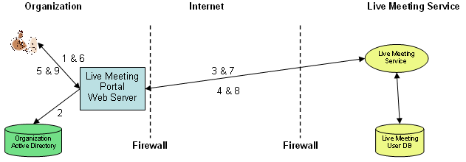
- The user clicks the Portal Change Password URL in Internet Explorer. Internet Explorer opens the Portal Change Password page and includes the user’s Windows identity when making the IIS Web Server request. IIS authenticates the user through Windows integrated authentication. If the user cannot be authenticated, the Portal reports the error to the user and does not proceed.
- The Portal retrieves the user’s Windows domain name and user ID from IIS, and it retrieves the user’s attributes from Active Directory. The Portal determines whether the user is entitled to use Live Meeting based upon the user’s Active Directory group membership. If the user is not entitled to use Live Meeting, the Portal redirects the user to the Denied Web page.
- The Portal calls the Live Meeting service GetUser XML API to determine if the user has a Live Meeting account. This API looks for an authenticated user’s e-mail ID in Active Directory and matches it to a Live Meeting account with the same e-mail ID. This and all subsequent XML API calls between the Portal and the Live Meeting service are performed using SSL. All XML API calls are performed under the identity of a Live Meeting administrator account specified by the Portal administrator when the Portal was configured.
- The Live Meeting service returns information regarding the user’s Live Meeting account.
- If the user does not have a Live Meeting account, the Portal redirects the user to the Portal’s Create Web page. If the user has a Live Meeting account, the Portal prompts the user to enter a new Live Meeting password.
- The user enters a new Live Meeting password and clicks Submit.
- The Portal validates the password the user entered to ensure that the password meets the policy and complexity requirements specified in the Live Meeting conference center.
- If the password is invalid, the Portal displays an error and allows the user to select another password.
- If the password is valid, the Portal calls the Live Meeting service ModifyUser XML API, passing the new password entered by the user.
- The Live Meeting service updates the Live Meeting account password and returns an XML API response indicating that the account password was successfully updated.
- The Portal informs the user that the Live Meeting password was updated.

Deactivating and Deleting an Account
When a user leaves the organization and the Windows account is deactivated, the user cannot log in to Live Meeting through the Portal. If the Live Meeting password is unknown to the user, that person cannot access the Live Meeting service directly. This prevents the deactivated user from accessing the Live Meeting service. Because the user cannot access the Live Meeting service, it is not essential that the administrator delete the user’s Live Meeting account immediately; however, it is best to deactivate and eventually delete obsolete Live Meeting accounts. This is accomplish by using the Portal Web methods.
If users know their Live Meeting password, they can circumvent the Portal by logging in to the Live Meeting service directly. To prevent this, disable or delete users Live Meeting accounts when they leave the organization. Do this by:
- Using the Portal’s DeactiveAccount or DeleteAccount Web methods to deactivate or delete the user’s Live Meeting account. It’s best to do this as a standard part of administrative procedures along with revoking Windows and e-mail accounts.
- Deleting the Live Meeting account manually through the Live Meeting service account management Web pages for administrators.

Keyboard Shortcuts for Common Portal Tasks
You can use the following keyboard shortcuts to perform common tasks in the portal interface:
- ALT + 0 allows you to take control of the main content window.
- ALT + 1 allows you to log in to Live Meeting.
- ALT + 2 allows you to view the portal Home page.
- ALT + 6 allows you to view Help for the portal.

Administrator’s Guide
This section is written for people who will be in the administrator role in Live Meeting.

Planning the Installation
Before you install the Portal, plan to make the Portal meet the following criteria:
- Scalable
- Available
- Reachable
- Secure

Scalable
If large numbers of Live Meeting users will be signing in to Live Meeting concurrently, you can deploy the Portal on two or more Web servers located behind a hardware or software load balancer. Clients access the Web servers using a common domain name with a single virtual IP address. The load-balancing hardware or software intercepts each incoming HTTP request and directs it to one of the Web servers in the cluster.
The Portal can be used with a variety of load-balancing systems including Windows Network Load Balancing (NLB). Windows NLB is included as part of Microsoft Windows Server™ 2003, Microsoft Windows 2000 Advanced Server, and Microsoft Windows 2000 Datacenter Server, operating systems. The Portal does not maintain session state across client calls; you are not required to use load-balancing hardware or software to maintain the session state.

Available
You may want to deploy two or more copies of the Portal Web application on different Web servers for availability. This permits users to sign in to Live Meeting even if a Portal Web server fails. Do this by installing the Portal on two or more Web servers located behind a load balancer (hardware or software) as previously described for scalability.

Reachable
You can deploy a Portal that is easily reached from the Internet. This is useful if members of your organization must access the Portal while traveling, working from home, or visiting remote locations. Alternatively, deploy the Portal inside your firewall and require users to access the Portal through a VPN connection.
If you make your Portal reachable from the Internet, consider deploying the Portal Web server in a perimeter network to help implement security measures. An Internet-visible Portal Web server should be using Basic authentication and SSL, or some similar security measures.

Secure
The Web site where you install the Portal must be secure (for example, configured to use SSL).

Upgrading from Version 1 of the SSO Portal
If you are upgrading from Version 1 of the SSO Portal, the state information from your previous installation will not be automatically retained. You must do the following before installing the Portal:
- Backup any customized HTML pages.
- Export and save the Portal configuration files using the portal interface.
- Uninstall the existing SSO portal.
- Move the Portal configuration file, Portalexport.config, to the following folder:
C:\Program Files\Microsoft Office\Live Meeting 7\Intranet Portal\Portal\PortalExport
When you have performed these steps, use the "Installation" procedure in the next section, "Installing the Portal" to install the Portal. When you have installed the new portal, import the Portal configuration files you exported above.

Installing the Portal
Before installing the Portal, ensure you meet the hardware and software requirements.
If you experience issues during or after installation, see the appendix, “Troubleshooting Portal Installation.”

Hardware Requirements
The hardware requirements for the Portal are modest because almost all the work is done by Active Directory and the Live Meeting service. The Portal maintains no individual user information. It retrieves all user information from Active Directory and the Live Meeting service. The Portal does relatively little computation on the Web server. The primary role of the Portal is to extract information from Active Directory and to use the Live Meeting service XML APIs to perform Live Meeting login and account maintenance.
The Portal also keeps very little information permanently on the disk. The Portal maintains a small XML Portal.config file for holding Portal configuration information. The Portal optionally writes event logs that record every Portal action. You control which events are logged when configuring the Portal.
The Portal Web server must meet the following minimum hardware requirements:
- 733 MHz or higher processor
- 512-MB RAM
- 10-GB free disk space

Software Requirements
The Portal Web server must meet the following software requirements:
- Microsoft Windows Server 2003 Standard Edition, Microsoft Windows Server 2003, Enterprise Edition, or Microsoft Windows Server 2003, Datacenter Edition, operating systems
- Microsoft Internet Information Services with ASP.NET
- Microsoft .NET Frameworks version 1.1 or later
- Microsoft Internet Explorer version 5.01 or later

Security Requirements
The Web site where you install the Portal must be secure (for example, configured to use SSL).

Installation
Install the Portal as follows:
- Run Setup.exe from the install directory, or from any convenient location. Running this file will automatically start Setup.msi.
- Setup creates shortcuts in the Start menu and Internet Explorer Favorites folder to help you quickly get to the Portal Web pages. These shortcuts are created from the Live Meeting Portal Configuration page in Setup.
- Specify the virtual directory, port number, IP address, and host header for the Portal Web server in the Select Virtual Directory page as shown in figure 6.
Figure 6 Specifying the Virtual Directory and Port number
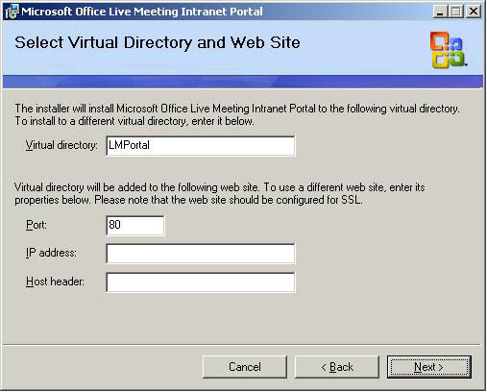
- When Setup is finished, you can configure the Portal.
If you experience issues during or after installation, see the appendix, “Troubleshooting Portal Installation.”

Installing an Additional Instance of the Portal
You can install two or more instances of the Portal on a single server. This is useful if you have two or more Live Meeting Conference Centers. For example, you might have one Live Meeting Conference Center for support and another for training. Each Portal works with a single Live Meeting Conference Center. Both Portals can be installed on the same server.
Note: If you want to remove this additional portal instance at a later time, you must manually uninstall it. Simply deleting the virtual directory will not remove the additional portal instance.
To install two or more instances of the Portal on a single server:
- Install the first instance of the Portal as previously described.
- Create a new Portal Web site directory to contain the additional Portal instance. For example, if the original Portal instance is contained in directory C:\Program Files\Microsoft Office Live Meeting \LMPortal create a new directory, such as C:\Program Files\Microsoft Office Live Meeting\LMPortal2.
- Copy all the files in the original Portal Web site directory to the new Portal Web site directory. This includes the contents of the \Intranet Portal\Portal and Rich Content folder.
- Start Internet Information Services. Click Start, point to All Programs, point to Administrative Tools, and then click Internet Information Services.
- In the tree view control in the left pane, expand %machinename%(local computer), Web Sites, and then Default Web Site.
- Start the Virtual Directory Creation Wizard by right-clicking Default Web Site and clicking New, Virtual Directory.
- In the Virtual Directory Creation Wizard click Next.
- Enter the alias you want to assign to the new virtual directory in the Virtual Directory Alias dialog box. For example, LMPortal2. Click Next.
- Enter the name of the new Portal Web site virtual directory you created in the Directory box of the Web Site Content Directory dialog box. For example: C:\Program Files\Microsoft Office Live Meeting\LMPortal2. Click Next.
- Ensure that the Read and Run scripts check boxes are checked in the Access Permissions dialog box. Click Next.
- Click Finish to complete the Virtual Directory Creation Wizard.
- In the Internet Information Services tree view control, right-click the virtual directory you just created and select Properties.
- On the Virtual Directory property page verify that an Application name is present. If it is not, click Create to create an application.
- Select the Directory Security tab.
- Within Anonymous access and authentication click Edit.
- If Anonymous access is selected, click it to clear the check mark.
- Click the check boxes for the forms of Authenticate access you want to support. For example, select Integrated Windows authentication to allow authenticated Windows users to access the Portal.
- Click OK to save and exit the Authentication Methods dialog box.
- Click OK to save and exit the Properties dialog box.
- On the server desktop, open the folder containing the new instance of the Portal (for example, C:\Program Files\Microsoft Office\Live Meeting\LMPortal2\Intranet Portal\Portal).
- Right-click the Portal.config file, and then click Properties.
- In the Properties dialog box, in the Security tab, click Add, then enter the object name as Network Server, and then click OK.
- In the Properties dialog box, next to Network Service, click Full Control.
- Open the folder containing the PortalExport folder (for example, C:\Program Files\Microsoft Office\Live Meeting 7\Intranet Portal\Portal).
- Right-click the PortalExport folder, and then click Properties.
- In the Properties dialog box, in the Security tab, click Add, then enter the object name as Network Server, and then click OK.
- In the Properties dialog box, next to Network Service, click Full Control.
- Start Internet Explorer and browse to the Configure.aspx Web page in the virtual directory you just created. Double-click the file to configure the new Portal instance.
If you experience issues during or after installation, see the appendix, “Troubleshooting Portal Installation.”

Configuring the Portal
This section covers Web server security, configuring a portal or multiple portals, and steps you through the Web Portal Configuration page.

Web Server Security
Setup configures the Portal Web site to require integrated Windows authentication. As a result, only authenticated Windows users are allowed to access the Portal Web pages.
If you deploy a Portal in the perimeter network and make it accessible from outside the firewall, you must configure the Portal Web site to help secure it for Internet access. You should use normal IIS Web Server security features to help secure the Portal Web site. For example, use Basic authentication and SSL. If you installed two or more instances of the Portal on a single server, provide security for all Web sites where the portal is installed.
You must choose an IIS authentication mechanism that assigns the Web user a Windows identity. This is essential because the Portal requires the user’s Windows identity to locate the user in Active Directory.
You can specify IP address restrictions to help ensure that your Portal is only accessed from IP addresses that you trust. For more information about granting and denying access to computers, see the IIS Documentation.
Note
Refer to the IIS documentation for more information about IIS security.

Considerations for Macintosh Clients Using Safari
A Portal user running the Safari browser on a Macintosh computer cannot access the Portal under normal security provisions. However, you can manually configure the Portal virtual directory settings in IIS to allow access to Safari users.
By default, the Portal uses SSL to provide security. In this case, when a user tries to access any page or XML Web service method using a URL that begins with http://, the Portal redirects the user to corresponding https URL. This redirection happens as part of the ASP.NET code.
By default, the Portal also uses Integrated Windows authentication to authenticate users. Because Safari does not support this authentication method, the Portal does not automatically communicate with Safari clients. Safari supports a different security method, called Basic authentication. To allow users access to the Portal from Safari, you must manually configure IIS for “Basic authentication”.
Be aware that this solution changes your Portal’s security. Basic authentication is less secure than Integrated Windows authentication, because it sends the user’s password over the network without data encryption. A person attempting to compromise a Safari user’s system security might use a protocol analyzer to examine user passwords during the authentication process.
Also, during the authentication process, the Portal does not redirect HTTP requests to https requests. If a Safari user accesses the Portal using an HTTP URL instead of an https URL, the password for Basic authentication is sent in clear text form unless you enable the “Require SSL” setting in IIS along with “Basic authentication” setting.
Be aware that as part of enforcing SSL using IIS setting, the Portal cannot redirect an HTTP request to an https request. If you enforce the SSL using IIS setting and a user accesses a Portal page using an HTTP URL, the user will receive an error message.
To enable access to EP from Safari, perform the following steps.
Note: All steps provided here assume that you are using IIS 6.0. If you are using a different version, consult your IIS documentation.
- On the server running the Portal, start IIS.
- Open the properties page for the Portal virtual directory. (Right-click the virtual directory in the tree, and then click Properties.)
- In the Directory Security tab, next to Authentication and access control, click the Edit button.
- In the Authentication Methods dialog box, click Basic authentication, and then click OK.
- In the Directory Service tab, next to Secure Communications, click the Edit button.
- In the Secure Communications dialog box, click Require secure channel (SSL), and then click OK.

Configuring the Portal
The Portal administrator configures the Portal through the Portal Configuration Web page.
All Portal configuration information is stored in the Portal configuration file. The Portal configuration file, Portal.config, is an XML file in the Portal Web site directory. When the Portal is installed, a preinitialized Portal configuration file is installed in this directory. When the Portal Web application is opened, the Portal reads the Portal configuration file, validates the configuration information in the file, and loads the configuration information into the Portal Configuration object in memory. While the Portal is running, it always uses the configuration information contained in the Portal Configuration object.
When you configure the Portal through the Configure Web page, the Portal reads the Portal configuration file again and loads the configuration information into a Portal Configuration Copy object in memory. If you modify configuration information through the Configuration Web page, only the configuration information in the Copy object is affected. The Portal Web application continues to use the original configuration information in the Portal Configuration object. You can think of the Copy object as a temporary working draft that you can modify as often as you want. None of the changes take effect until you save them.

Portal Configuration Web Page
Configure the Portal using the Portal Configuration Web page. To configure the Portal, open Internet Explorer and browse to the Portal Configure.aspx Web page. By default, Portal Setup creates shortcuts to the configuration page. To access them, click Start, point to All Programs and click Live Meeting Portal. Alternatively, you can access them in the Internet Explorer Favorites folder under Live Meeting Portal.
The Configuration Web page contains five panels:
- Settings
- Roles
- Security
- Proxy
- Events
Browse between panels by clicking the panel buttons at the top of the page. Begin with the Settings panel.

Settings Panel
This section explains each of the entry points in the Settings panel.
Figure 7 The Settings panel
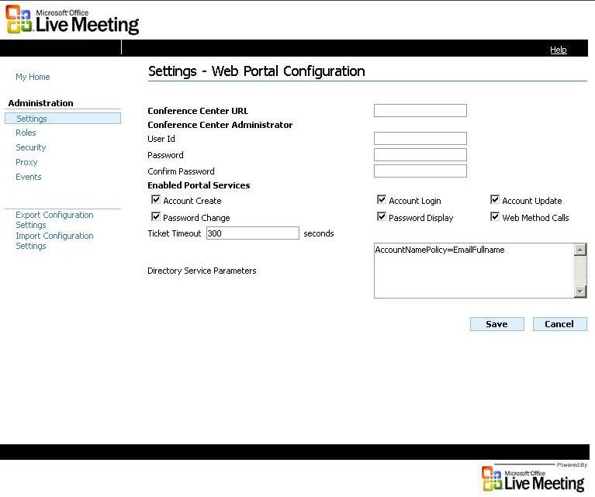
This specifies the Conference Center URL for the Live Meeting Conference Center. This URL should be supplied to you by your organization’s Live Meeting Conference Center administrator.

Conference Center URL
You should specify “https” as the protocol to help ensure that the information sent between the Portal and the Live Meeting service is encrypted. This is essential because Live Meeting passwords are transmitted without encryption unless https is specified.
Enter the Live Meeting user ID and password of a valid Live Meeting administrator account. This user ID and password is used to invoke the Live Meeting XML APIs. This value should be supplied to you by your organization’s Live Meeting Conference Center administrator.

Conference Center Administrator User Id and Password
The administrator password is stored in the Portal configuration file in encrypted form. The data is encrypted using the computer’s RSA public and private keys. The RSA keys are stored by the RSACryptoServiceProvider.
As Portal administrator, you control which Portal features are enabled (selected) by clicking the check box next to it. You can enable or disable (clear the check box) the following Portal features:

Enabled Portal Services
- Account Create
- Account Login
- Account Update
- Password Change
- Password Display
- Web Method Calls
By default, to help implement security measures, no options are selected. You must select the options that you want to use.
This controls whether users can create Live Meeting accounts through the Create Account Web page. It is normally selected.

Account Create
If this option is not selected, the Create Account Web page displays a message explaining that the Portal administrator has disabled Live Meeting account creation.
This option does not affect the CreateAccount Web method. By not selecting the Web Method Calls check box, you disable all Web methods, including CreateAccout. Web method calls is discussed later in this section.
Normally, you should rely upon the Portal to create all Live Meeting accounts. However, you can create Live Meeting accounts manually if you adhere to the following guideline:
Do not delete a user’s Live Meeting account without first disabling the user’s Windows account or removing the user from all Active Directory groups that are permitted to have Live Meeting accounts. If this rule is not observed, the Portal can recreate the user’s Live Meeting account. This occurs when the user browses to the Create Account Web page. The Portal determines that the user does not have a Live Meeting account and offers to create a new Live Meeting account for the user.
We recommend that you create all Live Meeting accounts through the Portal’s Create Account Web page and CreateAccount Web method. This ensures that Live Meeting accounts are created with the proper names and settings.
This controls whether users can log in to the Live Meeting service through the Portal. Both the Login Web page and the GetTicket Web method are controlled by Account Login, which is normally selected.

Account Login
When this option is not selected, the Login Web page displays a message explaining that the Portal administrator has disabled Live Meeting login and the GetTicket Web method returns the LoginDisabled error to Web method callers.
This controls whether the Portal automatically updates Live Meeting accounts to match Active Directory. It is normally selected.

Account Update
Whenever a user opens the Login or Change Password Web pages, or a program uses the GetTicket or ChangePassword Web methods, the Portal verifies that the Live Meeting account is active. This also verifies that the current Live Meeting account settings match the user’s current Active Directory settings. The Portal verifies the following settings and updates the ones indicated:
- userid
- username (updated)
- email
- isAdministrator (updated)
- isOrganizer (updated)
If the Portal determines that the user’s Live Meeting account settings have expired, it updates them to match Active Directory. The Portal does this by calling the Live Meeting ModifyUser XML API.
When you disable Account Update, the Portal still issues login tickets and changes Live Meeting account passwords provided the user is entitled to use Live Meeting based upon group membership. However, the Portal does not update the user’s Live Meeting account settings to match Active Directory. This can result in the user being logged into the Live Meeting service in the wrong Live Meeting role. For example, when users are demoted from an Active Directory Live Meeting administrators group to a Live Meeting organizers group, their Live Meeting account role will not automatically be demoted. When those users log in to Live Meeting, their former role remains. The same is true for users who are promoted from one Live Meeting role to another. They will remain in their former role until the Live Meeting account is updated by some other means.
Caution
If you choose to disable Account Update, carefully consider that decision before doing so.
If you select Account Update, you can still manually update Live Meeting accounts, but you should not update Live Meeting account settings that are updated by the Portal. If you manually update such a setting, the Portal will override your manual setting when the user next connects to Live Meeting through the Portal. Instead, change the corresponding settings in Active Directory. The Portal updates the Live Meeting account settings to match Active Directory the next time the user logs in to Live Meeting through the Portal.
This controls whether users can change their Live Meeting account password through the Change Password Web page. This option is normally selected only if the Password Display check box is selected.

Password Change
If this check box is not selected, the Change Password Web page displays a message explaining that the Portal administrator has disabled password change.
The Password Change option does not affect the ChangePassword Web method. You can disable all Web methods, including ChangePassword, by clearing the Web Method Calls check box.
This controls whether a user’s Live Meeting password is displayed when creating a Live Meeting account through the Create Account Web page. If this option is selected, the Live Meeting password is displayed to the user just after the account is created and just before the Welcome page is displayed.

Password Display
Not selecting the Password Display check box has the following advantages:
- The user does not have to remember the password.
- Because the user is not required to remember a Live Meeting password, the Portal can select very long, random passwords that are very difficult for someone to guess.
- Users can only log in to the Live Meeting service by first logging on to Windows and then going through the Portal. Once a user’s Windows account is disabled, the user cannot log in to Live Meeting. This simplifies administration and helps increase security.
Disabling the ability to display a password has limitations. You should select the Password Display check box in the following circumstances:
- When using the Live Meeting Add-In for Microsoft Outlook®. Those users must specify their Live Meeting password when configuring the Add-In.
- When allowing users to log in to the Live Meeting service directly without going through the Portal. This is useful when some Live Meeting users are located outside of the firewall and you do not provide either VPN connectivity to the Portal or an Internet-accessible Portal.
This controls whether applications may call the Portal Web methods.

Web Method Calls
Select this check box only if you have programs or scripts that use the Portal Web methods. Do not select it if you only access the Portal through the Portal Web pages. If in doubt, do not select this check box.
If this is selected, all Web method calls, except for GetTicket are rejected with the WebMethodCallsDisabled error.
This specifies the login ticket expiration time in seconds. It can range between 1 and 300 seconds, with it normally being 300. The login ticket returned by the Live Meeting service is a one-time only ticket. It expires when it is used or when the timeout period ends, whichever comes first.

Ticket Timeout
To help secure tickets, always send them over HTTPS using SSL encryption. Shorter ticket timeout values make the system slightly more secure, but that can lead to a ticket prematurely timing out if the network is slow.
This controls the behavior of the Directory Service. Only the AccountNamePolicy parameter is currently supported. The other options are only provided for backward compatibility.

Directory Service Parameters
AccountNamePolicy=EmailFullname
The Live Meeting user ID is the user’s full e-mail name as obtained from Active Directory. For example, Bill@contoso.com.
AccountNamePolicy=EmailNickname
The Live Meeting user ID is the user’s e-mail nickname as obtained from Active Directory. For example, Bill if the user’s full e-mail name is Bill@contoso.com.
AccountNamePolicy=LogonUsername
The Live Meeting user ID is the user’s Windows logon name. For example, Susan if the user’s Windows identity is contoso\Susan.
We strongly recommend that you use EmailFullname because it results in Live Meeting account identities that are unique and well known.
If you write a custom Directory Service, you can use this property to pass parameters to your custom Directory Service. This property can contain any string value. The recommended format is a CDF (comma delimited format) list of name and value pairs of the following form:
“name1=value1, name2=value2, name3=value3”

Click Save, and the Portal saves your configuration. Click Cancel and the Copy object is discarded along with any configuration changes you made.

Save and Cancel
The Portal does this by writing the configuration information contained in the Copy object to the Portal configuration file on disk and by immediately reading the updated Portal configuration file into the Portal Configuration object in memory. When you save the configuration, the new configuration information takes effect immediately.
Click Export to back up configuration information or to copy configuration information to another Portal Web server. When you click Export the Portal creates an empty Portal configuration file in the PortalExport folder (contained in the Portal Web site folder), names the file PortalExport.config, and copies the configuration information from the Portal Configuration Copy object to the PortalExport.config file. Export simply saves the configuration information to the PortalExport.config file. A confirmation message describes the action to be taken before the export occurs.

Export
Click Import to restore configuration information saved by clicking Export. The configuration information you import might have been exported from this Portal Web server or it might have been exported from another Portal Web server. When you click Import, the Portal reads the PortalExport.config file in the PortalExport folder (contained in the Portal Web site folder), and loads the configuration information into a Portal Configuration Copy object in memory. Once import completes, you can view the imported configuration information using the Configuration Web page and you can modify any configuration values. The imported configuration information only takes effect when you click Save. If you click Cancel, the imported configuration information is discarded along with any other changes you might have made.

Import

Configuring Multiple Portals
Note
Cancel, Save, Export, and Import appear on each of the panel pages.
You can use export and import to copy Portal configuration information from one Portal Web site to another. This is useful if you have two or more identical Portal Web sites and you want to keep their configurations synchronized.
Each Portal Web site requires its own copy of the Portal configuration file. We recommend that you designate one of your Portal Web sites as the master site. Make changes to the Portal configuration information on that site. Then use export to copy the master site configuration information to the PortalExport.config file.
Copy the PortalExport.config file from the master Portal Web site directory to the Portal Web site directories at each of the other Portal Web sites. Open Internet Explorer at each of those sites and browse to the Portal Configuration Web page. Click Import to load the configuration information from the PortalExport.config file.
Note that the Live Meeting administrator and Proxy Server passwords are not written to the PortalExport.config file. The password information stored in the Portal configuration file is encrypted using a public key pair that is stored only on the local computer. Encrypted password information written on one computer is unreadable on another. This helps make the encrypted passwords stored in the Portal configuration file more secure. You must reenter the Live Meeting administrator password at each Web site. You must also reenter the Proxy Server password, if appropriate. Click Save to save the configuration information at each site.
There is nothing unique about the master Portal Web site. Once the Portal configuration information has been copied to the other Portal Web sites, and passwords are entered on those sites, all sites become equal. You can choose a different master site each time you update and replicate the Portal configuration information.

Roles Panel
This section explains each of the entry points in the Roles panel.
Figure 8 The Roles panel
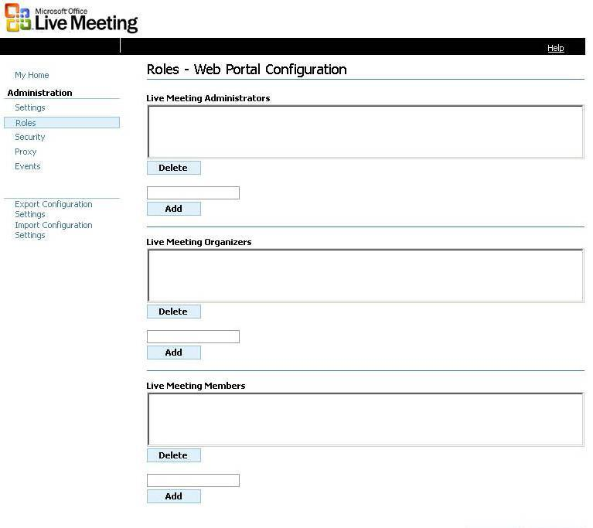
This specifies which Active Directory users and groups are Live Meeting administrators. Live Meeting users who are members of this list are issued a Live Meeting administrator account.

Live Meeting Administrators
To delete an entry from the list, select the entry and click Delete.
To add an entry to the list, enter an Active Directory user or group name in the box and click Add. The Portal verifies that the user or group name is valid by looking in Active Directory. If the name is valid, it is added to the list of Live Meeting administrator accounts contained in the list box. If the name is invalid, an error message appears at the bottom of the Web page.
You can enter a user or group name in the form %domainname%\%user or groupname%. If the %user or groupname% is unique in the Active Directory forest, you can omit the %domainname% and backslash. The Portal will determine the %domainname% by searching Active Directory for all user or group names matching the value entered. If you omit the %domainname% and Active Directory contains more than one user or group with that name, the Portal will report that the name was ambiguous and ask you to supply the %domainname%.
Valid values are:
%domainname%\%Active Directory security groupname% >
This must be the name of an Active Directory security group. Active Directory distribution group names (such as Microsoft Exchange distribution lists) are not permitted.
%domainname%\%Active Directory username%
This must be the name of an Active Directory user.
‘*’
Wild card “*” specifies that everyone is a Live Meeting administrator. When “*” is specified, it must be the only value in the list. When “*” is specified for Live Meeting administrators, both Live Meeting organizers and Live Meeting members must be empty. When “*” is specified for Live Meeting organizers, Live Meeting members must be empty.
<empty>
This specifies that no one is a Live Meeting administrator. Usually at least one user is designated as a Live Meeting administrator. If Live Meeting administrators, Live Meeting organizers, and Live Meeting members are all empty, the Portal administrator is warned that no one will be granted access to Live Meeting.
This specifies which Active Directory users and groups are Live Meeting organizers. If the Live Meeting user is a member of this list, that user is issued a Live Meeting organizer account.

Live Meeting Organizers
The rules for organizers and administrators are identical.
This specifies which Active Directory users and groups are Live Meeting members. If the Live Meeting user is a member of this list, the user is issued a Live Meeting member account.

Live Meeting Members
The rules for members and administrators are identical.
See the “Settings Panel” section earlier in this document for more information about Save, Cancel, Export, and Import.

Security Panel
This section explains each of the entry points in the Security panel.
Figure 9 The Security panel
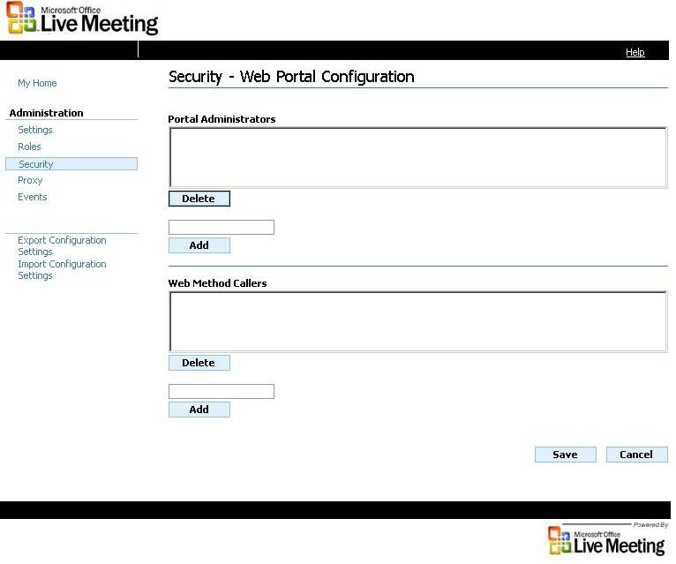
This specifies which Active Directory users and groups can configure the Portal through the Configure Web page.

Portal Administrators
To add an entry to the list, enter an Active Directory user or group name in the single line box and click Add. The Portal verifies that the user or group name entered is valid by looking in Active Directory. If the name is valid, it is added to the list of Portal Administrator accounts contained in the list box. If the name is invalid, an error message appears at the bottom of the Web page.
To delete an entry from the list, select the entry and click Delete.
You can enter a user or group name in the form %domainname%\%user or groupname%. If the %user or groupname% is unique in the Active Directory forest, you may omit the %domainname% and backslash. The Portal determines the %domainname% by searching Active Directory for all user or group names matching the value entered. If you omit the %domainname% and Active Directory contains more than one user or group with that name, the Portal reports that the name was ambiguous and requests the %domainname%.
Valid values are:
%domainname%\%Active Directory security groupname%
This must be the name of an Active Directory security group. Active Directory distribution group names (such as Exchange distribution lists) are not permitted.
%domainname%\%Active Directory username%
This must be the name of an Active Directory user.
<empty>
This specifies that no one, aside from the local administrator, is allowed to configure the Portal. The local administrator is always permitted to configure the Portal. Note that the wild card character “*” is not permitted.
This specifies which Active Directory users and groups can call the Portal Web methods.

Web Method Callers
If you do not have programs or scripts that call the Portal Web methods, leave this empty. If you are in doubt about having or using programs and scripts, leave this empty.
The rules for Portal administrators and Web method callers are identical with the following exception. If the Web Method Callers box is empty, no one is allowed to call the Portal Web methods including the local administrator.
See the “Settings Panel” section earlier in this document for more information about Save, Cancel, Export, and Import.

Proxy Panel
This section explains each of the entry points in the Proxy panel.
Figure 10 The Proxy panel
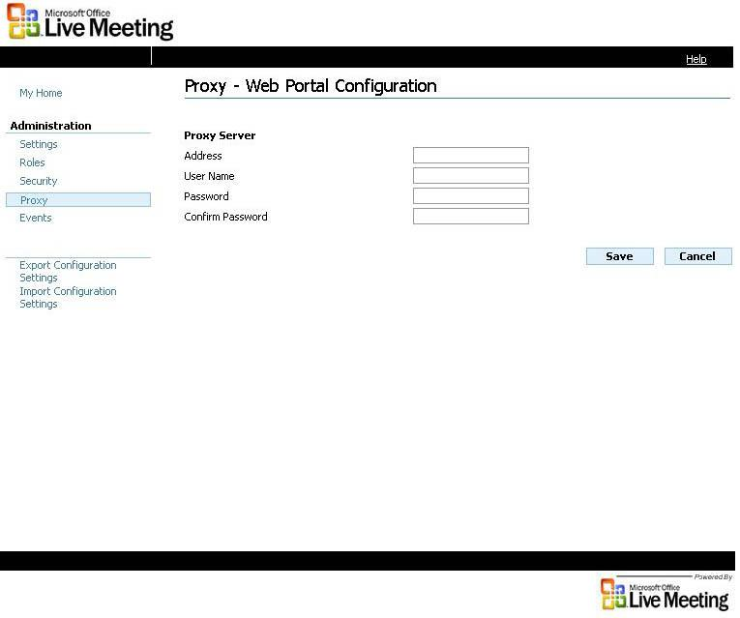
This specifies the URL of the proxy server, if any. A proxy server address must be specified when the Portal is required to connect to the Live Meeting service through a proxy server.

Address
If a proxy server address is specified and the proxy server requires authentication, then a proxy user name and proxy password must also be specified.
Valid values for proxy server address take the following form:
- http://www.contoso.com
The proxy server URL is without a port number.
- http://www.contoso.com:443
The proxy server URL has a port number.
This specifies the user name, if any, and is used to authenticate the user to the proxy server.

User Name
This specifies the password, if any, used to authenticate the user to the proxy server.

Password and Confirm Password
See the “Settings Panel” section earlier in this document for more information about Save, Cancel, Export, and Import.

Events Panel
This section explains each of the entry points in the Events panel.
Figure 11 The Events panel
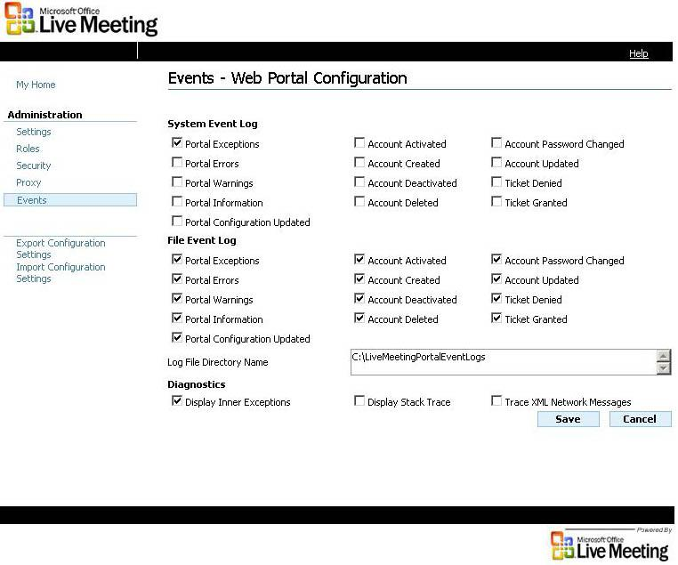
This controls which events and exceptions are written to the Windows Event Log. Configuration changes take effect as soon as the configuration is saved. We recommend that, at a minimum, you select Portal Exceptions.

System Event Log
This controls which events and exceptions are written to the File System Event Log. If no event types are selected, the File System Event Log is not opened and no events are written. Configuration changes take effect as soon as the configuration is saved. Usually all event types are selected.

File Event Log
The specifies the directory where File Event Logs are written. If the directory does not exist, the Portal creates it.

Log File Directory Name
If there are no File Event Log event types selected, the Log File Directory Name box can remain empty. If at least one event type is selected, enter a name in the box.
For more information about events, see “Portal Management” later in this document.
This specifies whether inner exceptions are displayed to the browser user when an exception occurs. We recommend selecting this option because the inner exceptions often contain helpful information.

Diagnostics: Display Inner Exception
This specifies whether a stack trace is displayed to the browser user when an exception occurs. This is usually not selected. However, select this check box when reporting problems to Microsoft because the stack trace might assist in diagnosing a problem.

Diagnostics: Display Stack Trace
This specifies whether the XML API requests and responses sent between the Portal and the Live Meeting service are logged to the File Event Logger. This is usually selected only when diagnosing network communications problems.

Diagnostics: Trace XML Network Messages
See the “Settings Panel” section earlier in this document for more information about Save, Cancel, Export, and Import.

Making Portal User Names Conform to Common Naming Conventions
Users of the portal can change their account details in Live Meeting. However, if they change these details, they might not be able to use the Portal. The Portal gets e-mail addresses from Active Directory and uses each address to identify the Live Meeting account for a particular user. For this reason, users should be discouraged from changing their e-mail addresses.
As a best practice, make sure that all users retain the same e-mail addresses that are generated for them by the portal. As an administrator, when you send e-mail informing users about the portal, you can include a recommendation that the users not change their e-mail address as it has been assigned by the portal.

Editing the Portal Configuration File
All Portal configuration information is stored in the Portal configuration file (Portal.config). The Portal configuration file is an XML file in the Portal Web site directory. When the Portal is installed, a preinitialized Portal configuration file is installed in this directory. When you configure the Portal through the Configuration Web page, the configuration information is stored in the Portal configuration file.
In rare circumstances you might want to manually edit the Portal configuration file.

To manually edit the Portal configuration file
- Make a copy of the current Portal configuration file to save it as a backup.
- Open Internet Explorer, browse to the Portal Configure Web page, and click Export. This creates the PortalExport.config file in the PortalExport folder (contained in the Portal Web site folder).
- Edit the PortalExport.config file using Microsoft Visual Studio® .NET, an XML editor, or Notepad. The file contains extensive comments to help guide you. If the XML editor supports XSD schema files, use the Portal configuration schema file (PortalConfigSchema.xsd) to validate the changes. The schema file is located in the Portal Web site bin directory.
- Save the updated PortalExport.config file in the Portal Web site directory.
- Open Internet Explorer, browse to the Portal Configure Web page, and click Import to load and verify the updated PortalExport.config file. This file is located in the PortalExport folder (contained in the Portal Web site folder).
If you receive any errors, correct them by editing and saving the PortalExport.config file, and click Import again.
- Enter the Live Meeting administrator password and the proxy server password, if any. Click Save to save the updated configuration information to the Portal.config file.

Managing the Portal
The Portal is designed to make management and performance monitoring easy.

Events
The Portal generates the following events:
Table 1 Event types generated by the portal
Event Type | Meaning
AccountActivated | A Live Meeting account was activated through the Portal.
AccountCreated | A Live Meeting account was created through the Portal.
AccountDeactivated | A Live Meeting account was deactivated through the Portal.
AccountPasswordChanged | A Live Meeting account password was changed through the Portal.
AccountUpdated | A Live Meeting account was updated through the Portal.
TicketDenied | A Live Meeting logon ticket was denied by the Portal.
TicketGranted | A Live Meeting logon ticket was granted by the Portal.
PortalInformation | This event is not used.
PortalWarnings | This event is not used.
PortalConfigurationUpdated | The Portal configuration was modified by the Portal administrator.
PortalExceptions | A run-time exception occurred.

Events are logged on the system where the Portal resides. Events can be logged to the System Event Log, the File Event Log, or both. You control which events are logged to each log file through the Events Panel on the Configuration Web page.
File Event Logs are text files. Each log record contains one Portal event. Each log record begins with the date and time that the event occurred. You can combine two or more log files and sort them in chronological order.
Specify the log file directory name where File Event Logs are written when configuring the Portal. If the log directory does not exist, the Portal creates it. The Portal creates a new log file each day and includes the date in the log file name in the following format:
PortalEventLog-YYYY-MM-DD.txt

Portal Event Types
Table 2 AccountActivated
Field | Content
Event Name | Account Activated
Type | Information
Event Id | 9002
Parameters | WindowsUserId  LMUserId  Name  Role

Table 3 AccountCreated
Field | Content
Event Name | Account Created
Type | Information
Event Id | 9003
Parameters | WindowsUserId  LMUserId  Name  Role

Table 4 AccountDeactivated
Field | Content
Event Name | Account Deactivated
Type | Information
Event Id | 9004
Parameters | WindowsUserId  LMUserId  Name  Role

Table 5 AccountDeleted
Field | Content
Event Name | Account Deleted
Type | Information
Event Id | 9005
Parameters | WindowsUserId  LMUserId  Name  Role

Table 6 AccountPasswordChanged
Field | Content
Event Name | Account Password Changed
Type | Information
Event Id | 9006
Parameters | WindowsUserId  LMUserId  Name  Role

Table 7 AccountUpdated
Field | Content
Event Name | Account Updated
Type | Information
Event Id | 9007
Parameters | WindowsUserId  LMUserId  OldName  OldEmail  OldRole  NewName  NewEmail  NewRole

Table 8 TicketDenied
Field | Content
Event Name | Ticket Denied
Type | FailureAudit
Event Id | 9001
Parameters | WindowsUserId  LMUserId  Name  Role  Status (Indicates the reason the ticket was not granted.)

Table 9 TicketGranted
Field | Content
Event Name | Ticket Granted
Type | SuccessAudit
Event Id | 9000
Parameters | WindowsUserId  LMUserId  Name  Role

Table 10 PortalConfigurationUpdated
Field | Content
Event Name | Portal Configuration Updated
Type | Information
Event Id | 9008
Parameters | WindowsUserId of the administrator making the change.

Table 11 Portal Exceptions
Field | Content
Event Name | Portal Exception
Type | Error
Event Id | 1000 - 1999
Parameters | Exception message and parameters  Inner exception messages  Stack trace

Maintaining Performance Counters
The Portal maintains performance counters. All Portal performance counters are contained in the performance counter category Live Meeting Portal in System Monitor.
The Portal maintains an instance of the performance counters for each IIS virtual directory created. This makes it possible to create two or more instances of the Portal on a single server. The performance counter instance name is derived from the IIS virtual directory name by dropping all backslashes present in the virtual directory name. For example, the virtual directory name, LMPortal\test\one, becomes performance counter instance name: LMPortaltestone.
After installing and configuring the Portal, monitor Portal performance as follows:
- Open System Monitor. Click Start, point to All Programs, point to Administrative Tools and then click Performance.
- In System Monitor click Add (plus sign) on the toolbar to add new performance counters.
- In the Add Counters dialog box, click the Performance object drop down list and click Live Meeting Portal.
- Click the Portal virtual directory you want to monitor from Select instances from list.
- Click the counters you want to monitor from Select counters from list.
- Click Add and then click Close.
The Portal maintains the following performance counters:
Table 12 Portal performance counters
Counter Name | Type | Description
AccountActivatedCount | NumberofItems32 | The number of Live Meeting accounts activated.
AccountActivatedRate | RateOfCountsPerSecond32 | The rate at which Live Meeting accounts are activated in accounts per second.
AccountCreatedCount | NumberofItems32 | The number of new Live Meeting accounts created.
AccountCreatedRate | RateOfCountsPerSecond32 | The rate at which Live Meeting accounts are created in accounts per second.
AccountDeactivatedCount | NumberofItems32 | The number of Live Meeting accounts deactivated.
AccountDeactivatedRate | RateOfCountsPerSecond32 | The rate at which Live Meeting accounts are deactivated in accounts per second.
AccountDeletedCount | NumberofItems32 | The number of Live Meeting accounts deleted.
AccountDeletedRate | RateOfCountsPerSecond32 | The rate at which Live Meeting accounts are deleted in accounts per second.
AccountPasswordChangedCount | NumberofItems32 | The number of Live Meeting account password changes.
AccountPasswordChangedRate | RateOfCountsPerSecond32 | The rate at which Live Meeting account passwords are changed in accounts per second.
AccountUpdatedCount | NumberofItems32 | The number of Live Meeting accounts updated.
AccountUpdatedRate | RateOfCountsPerSecond32 | The rate at which Live Meeting accounts are updated in accounts per second.
TicketDeniedCount | NumberofItems32 | The number of tickets denied.
TicketDeniedRate | RateOfCountsPerSecond32 | The rate at which tickets are denied in tickets per second.
TicketGrantedCount | NumberofItems32 | The number of tickets granted.
TicketGrantedRate | RateOfCountsPerSecond32 | The rate at which tickets are granted in tickets per second.

Uninstalling the Portal
To uninstall the Portal, click Start, point to Control Panel, and then click Add or Remove Programs. Select Microsoft Office Live Meeting Portal and click Remove.
Important
Do not uninstall the Portal until the last instance of the Portal on the system is deleted. Uninstalling the Portal deletes the Portal performance counters and unregisters the Portal event classes that are written to the Application event log.
To delete an instance of the Portal without uninstalling the Portal
- Open Internet Information Services. Click Start, point to All Programs, point to Administrative Tools, and then click Internet Information Services.
- In the tree view control on the left pane, expand %machinename% (local computer), Web Sites, and then Default Web Site.
- Right-click the virtual directory of the Portal instance that you want to delete and click Delete. Click Yes to confirm that you want to delete the virtual directory.
Note
You might need to stop and restart IIS before you can delete the Portal instance. Do this by right-clicking %machinename% (local computer) and selecting All tasks, Restart IIS. Click OK to confirm that you want to restart IIS. After IIS restarts delete the virtual directory.

Programmer’s Guide
This section is written for people who will be in the Live Meeting programmer role.
Figure 12 Web Methods
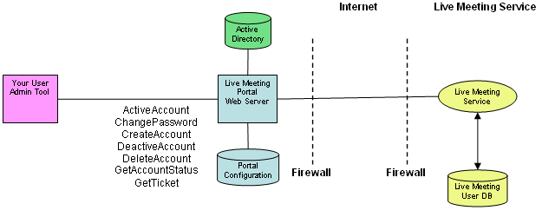

The Portal Web methods allow you to programmatically manage Live Meeting accounts. For example, you might invoke the CreateAccount Web method whenever a new user joins the organization. Similarly, you might invoke the DeactiveAccount Web method whenever a user leaves the organization.
The following briefly describes each of the Portal Web methods:
- ActivateAccount. Activates a Live Meeting account.
- ChangePassword. Changes the password for a Live Meeting account.
- CreateAccount. Creates a new Live Meeting account.
- DeactivateAccount. Deactivates the Live Meeting account.
- DeleteAccount. Deletes the Live Meeting account.
- GetAccountStatus. Gets the status of a Live Meeting account.
- GetTicket. Retrieves a login ticket.
Note: The following paragraph applies to all Portal Web methods.
The IIS Web server that is hosting the Portal Web application authenticates the Web method caller using Windows integrated authentication. The Portal obtains the Windows identity of the caller and verifies that the caller is entitled to use Web methods. Only users and groups who are included in the Web method callers list can use Web methods. The Portal administrator specifies the groups and users in this list when configuring the Portal. This ensures that only authorized users can use Web methods.
The GetTicket Web method is different from the other methods because it is always called under the identity of the Windows user who is requesting the login ticket. Any Windows user can call the GetTicket Web method. Only users who have a Live Meeting account and who are authorized to use Live Meeting based upon their Active Directory group membership are issued a login ticket.

Sample Web Method Client in C#

using System;
using System.Net;
using Microsoft.LiveMeeting;

namespace WebSample
{
class WebSampleClass
{
[STAThread]
static void Main(string[] args)
{
try
{
LMWebService lmWebService = new LMWebService();
lmWebService.Url = "http://localhost/LMPortal/LMWebService.asmx";
lmWebService.Credentials = CredentialCache.DefaultCredentials;

string lmUserId;
string name;
string role;
string windowsId = @"contoso\bill";

string outcome = lmWebService.GetAccountStatus(
windowsId, out lmUserId, out name, out role);
if ((outcome == "HasAccount_Entitled") |
(outcome == "HasAccount_NotEntitled") |
(outcome == "NoAccount_Entitled") |
(outcome == "NoAccount_NotEntitled"))
{
Console.WriteLine("Account status obtained for user " + windowsId);
}
else
{
Console.WriteLine("Account status not obtained for user " +
windowsId +
" due to error " + outcome);
}
}
catch (Exception ex)
{
Console.WriteLine("Exception=" + ex.Message);
}
}
}
}

Compile the sample as follows:
- Install the Portal. Portal Setup installs the LMWebServiceProxy.dll file in the Proxy Web server bin directory.
- Create an empty file named WebSample.cs; copy the sample code into it.
- Compile the sample using the following command, but enter the actual path to the LMWebServiceProxy.dll file.
csc.exe /R:LMWebServiceProxy.dll;System.Web.Services.dll WebSample.cs

Web Method Call Outcomes
All Web methods return an outcome in string form. The following outcomes are possible:
Table 13 Web method call outcomes
Outcome | Meaning
Failure_InvalidPassword | The password is invalid. It does not meet the password length, password character set, or password complexity requirements.
HasAccount_Entitled | The Windows user specified in the call has a Live Meeting account and is entitled to have it.
HasAccount_NotEntitled | The Windows user specified in the call has a Live Meeting account but is no longer entitled to have it based upon that user’s current Active Directory group membership.
LoginDisabled | The Portal administrator has disabled Live Meeting login. This outcome is only returned by the GetTicket Web method.
NoAccount_Entitled | The Windows user specified in the call does not have a Live Meeting account but is entitled to have one.
NoAccount_NotEntitled | The Windows user specified in the call does not have a Live Meeting account and is not entitled to have one.
NotInDirectory | The Windows user specified in the call could not be found in the directory service. Because the Portal could not find the Windows user in Active Directory it could not determine the users Live Meeting account identifier, and it could not determine whether the user has a Live Meeting account.
Success | The call was successful.
Unauthorized | The caller is not authorized to invoke Portal Web methods because that caller is not a member of the Portal WebMethodCallers directory group.
WebMethodCallsDisabled | The Portal administrator has disabled all Web method calls.

ActivateAccount
Activates a Live Meeting account.
public string ActivateAccount(string windowsId)

Parameters
windowsId
Specifies the Windows identity of the user to be activated.
Table 14 Return values for ActivateAccount
Outcome | Meaning
HasAccount_NotEntitled | Account not activated. See the Web method call outcomes table for details.
NoAccount_Entitled | Account not activated. See the Web method call outcomes table for details.
NoAccount_NotEntitled | Account not activated. See the Web method call outcomes table for details.
NotInDirectory | Account not activated. See the Web method call outcomes table for details.
Success | Account activated.
Unauthorized | Account not activated. See the Web method call outcomes table for details.
WebMethodCallsDisabled | Account not activated. See the Web method call outcomes table for details.

The ActivateAccount Web method works as follows:

Remarks
- The caller invokes the Web method specifying the Windows identity of the user for whom the Live Meeting account is to be activated.
- IIS authenticates the caller using Windows integrated authentication.
- The Portal does the following:
- Verifies that Web method calls are enabled. If not, it returns WebMethodCallsDisabled.
- Verifies that the caller is a member of a Windows security group listed in Web method callers. If not, it returns Unauthorized.
- Calls Active Directory to retrieve the attributes for the user whose windowsId was specified in the call. If the user cannot be found in Active Directory, it returns NotInDirectory.
- Calls the Live Meeting GetUser XML API to retrieve the user’s Live Meeting account information. If the user does not have an account or is not entitled to have an account, it returns NoAccount_Entitled, NoAccount_NotEntitled, or HasAccount_NotEntitled as appropriate.
- Calls the ModifyUser XML API and deletes the expireTime account attribute. This activates the account.
- Returns Success if the ModifyUser XML API call is successful; otherwise, it returns the XML API error to the caller.

Example:
LMWebService lmWebService = new LMWebService();
lmWebService.Url = "http://localhost/LMPortal/LMWebService.asmx";
lmWebService.Credentials = CredentialCache.DefaultCredentials;

string windowsId = @"contoso\bill";
string outcome = lmWebService.ActivateAccount(windowsId);
if (outcome == "Success")
{
Console.WriteLine("Account activated for user " + windowsId);
}
else
{
Console.WriteLine("Account not activated for user " + windowsId +
" due to error " + outcome);
}

ChangePassword
Changes the password for a Live Meeting account.
public string ChangePassword(string windowsId,
string password
out string lmUserId,
out string name,
out string role)

Parameters
windowsId
Specifies the Windows identity of the user whose Live Meeting account password should be changed.
password
Specifies the new Live Meeting password.
lmUserId
Returns the user’s Live Meeting user ID.
name
Returns the user’s Live Meeting name.
role
Returns the user’s Live Meeting role: ADMINISTRATOR, ORGANIZER, or MEMBER. New roles might be introduced in the future.

Table 15 Return values for ChangePassword
Outcome | Meaning
Failure_InvalidPassword | The password is invalid. It does not meet the password length, password character set, or password complexity requirements.
HasAccount_NotEntitled | Password not changed. See the Web method call outcomes table for details.
NoAccount_Entitled | Password not changed. See the Web method call outcomes table for details.
NoAccount_NotEntitled | Password not changed. See the Web method call outcomes table for details.
NotInDirectory | Password not changed. See the Web method call outcomes table for details.
Success | Password changed.
Unauthorized | Password not changed. See the Web method call outcomes table for details.
WebMethodCallsDisabled | Password not changed. See the Web method call outcomes table for details.

Remarks
The ChangePassword Web method functions as follows:
- The caller invokes the Web method specifying the password and the Windows identity of the user for whom the Live Meeting account password is to be changed.
- IIS authenticates the caller using Windows integrated authentication.
- The Portal does the following:
- Verifies that Web method calls are enabled. If not, it returns WebMethodCallsDisabled.
- Verifies that the caller is a member of a Windows security group listed in Web Method Callers. If not, it returns Unauthorized.
- Validates the password to ensure that the password meets the password length, password character set, and password complexity requirements. If not, it returns Failure_InvalidPassword.
- Calls Active Directory to retrieve the attributes for the user whose windowsId was specified in the call. If the user cannot be found in Active Directory, it returns NotInDirectory.
- Calls the Live Meeting GetUser XML API to retrieve the user’s Live Meeting account information. If the user does not have an account or is not entitled to have an account, it returns NoAccount_Entitled, NoAccount_NotEntitled, or HasAccount_NotEntitled as appropriate.
- Calls the ModifyUser XML API and updates the Live Meeting account password.
- Returns Success if the ModifyUser XML API call is successful; otherwise, it returns the XML API error to the caller.

Example
LMWebService lmWebService = new LMWebService();
lmWebService.Url = "http://localhost/LMPortal/LMWebService.asmx";
lmWebService.Credentials = CredentialCache.DefaultCredentials;

string lmUserId;
string name;
string role;
string password = @"ABCDwxyz!$%^1234";
string windowsId = @"contoso\bill";

string outcome = lmWebService.ChangePassword(windowsId, password, out lmUserId, out name, out role);
if (outcome == "Success")
{
Console.WriteLine("Password changed for user " + windowsId);
}
else
{
Console.WriteLine("Password not changed for user " + windowsId +
" due to error " + outcome);
}

CreateAccount
Creates a new Live Meeting account.
Creates a new Live Meeting account.
public string CreateAccount(string windowsId,
out string lmUserId,
out string name,
out string role,
out string password,
out string welcomePageUrl)

Parameters
windowsId
Specifies the Windows identity of the user whose Live Meeting account password should be created.
lmUserId
Returns the user’s Live Meeting user ID.
name
Returns the user’s Live Meeting name.
role
Returns the user’s Live Meeting role: ADMINISTRATOR, ORGANIZER, or MEMBER. New roles might be introduced in the future.
password
Returns the user’s Live Meeting password.
welcomePageUrl
Returns the welcomePageUrl appropriate to the user’s role.
Table 16 Results for CreateAccount
Outcome | Meaning
HasAccount_Entitled | The account was not created because the user already has a Live Meeting account.
HasAccount_NotEntitled | The account was not created because the user is not entitled to have a Live Meeting account based upon the user’s Active Directory group membership.
NoAccount_NotEntitled | The account was not created because the user is not entitled to have a Live Meeting account based upon that user’s Active Directory group membership.
NotInDirectory | The account was not created. See the Web method call outcomes table.
Success | The account was created.
Unauthorized | The account was not created. See the Web method call outcomes table.
WebMethodCallsDisabled | The account was not created. See the Web method call outcomes table.

You can issue Live Meeting accounts to new users when they first join the organization just as you issue these users Windows and e-mail accounts. This is especially important for organizations that use ACL-protected meetings because the new user cannot be invited to an ACL-protected meeting until a Live Meeting account has been issued.

Remarks
The CreateAccount Web method functions as follows:
- The caller invokes the Web method specifying the Windows identity of the user for whom the Live Meeting account is to be created.
- IIS authenticates the caller using Windows integrated authentication.
- The Portal does the following:
- Verifies that Web method calls are enabled. If not, it returns WebMethodCallsDisabled.
- Verifies that the caller is a member of a Windows security group listed in Web method callers. If not, it returns Unauthorized.
- Calls Active Directory to retrieve the attributes for the user whose windowsId was specified in the call. If the user cannot be found in Active Directory, it returns NotInDirectory.
- Calls the Live Meeting GetUser XML API to retrieve the user’s Live Meeting account information. If the user already has an account or is not entitled to have an account, it returns HasAccount_Entitled, HasAccount_NotEntitled, or NoAccount_NotEntitled as appropriate.
- Generates a random Live Meeting account password for the new account.
- Calls the CreateUser XML API to the new Live Meeting account.
- Returns Success if the CreateUser XML API call is successful; otherwise, it returns the XML API error to the caller.

Example
LMWebService lmWebService = new LMWebService();
lmWebService.Url = "http://localhost/LMPortal/LMWebService.asmx";
lmWebService.Credentials = CredentialCache.DefaultCredentials;

string lmUserId;
string name;
string role;
string password;
string welcomePageUrl;
string windowsId = @"contoso\bill";

string outcome = lmWebService.CreateAccount(windowsId, out lmUserId, out name, out role, out password, out welcomePageUrl);
if (outcome == "Success")
{
Console.WriteLine("Account created for user " + windowsId);
}
else
{
Console.WriteLine("Account not created for user " + windowsId +
" due to error " + outcome);
}

DeactivateAccount
Deactivates the Live Meeting account.
public string DeactivateAccount(string windowsId)

Parameters
windowsId
Specifies the Windows identity of the user to be deactivated.
Table 17 Return values for DeactivateAccount
Outcome | Meaning
NoAccount_Entitled | The account was not deactivated because the Live Meeting account was not found for the user.
NoAccount_NotEntitled | The account was not deactivated because the Live Meeting account was not found for the user.
NotInDirectory | The account was not deactivated. See the Web method call outcomes table.
Success | The account was deactivated.
Unauthorized | The account was not deactivated. See the Web method call outcomes table.
WebMethodCallsDisabled | The account was not deactivated. See the Web method call outcomes table.

You can automate Live Meeting account deletion by invoking the DeleteAccount Web method whenever a user leaves the organization. This Web method deletes the user’s Live Meeting account and it deletes all information regarding meetings organized by the user.

Remarks
You might want to automate the process by using the DeactivateAccount Web method to deactivate a user’s Live Meeting account when they leave the organization rather than deleting the account. This has two advantages:
- If the account is deactivated, you can reactivate the account later without loosing account information.
- If the account is deactivated, you preserve the recordings and other meeting related data resulting from the meetings organized by the user.
The DeactivateAccount Web method functions as follows:
- The caller invokes the Web method specifying the Windows identity of the user for whom the Live Meeting account is to be deactivated.
- IIS authenticates the caller using Windows integrated authentication.
- The Portal does the following:
- Verifies that Web method calls are enabled. If not, it returns WebMethodCallsDisabled.
- Verifies that the caller is a member of a Windows security group listed in Web Method Callers. If not, it returns Unauthorized.
- Calls Active Directory to retrieve the attributes for the user whose windowsId was specified in the call. If the user cannot be found in Active Directory, it returns NotInDirectory.
- Calls the Live Meeting GetUser XML API to retrieve the user’s Live Meeting account information. If the user does not have an account or is not entitled to have an account, it returns NoAccount_Entitled, NoAccount_NotEntitled, or HasAccount_NotEntitled as appropriate.
- Calls the ModifyUser XML API and sets the expireTime account attribute to the current date and time. This deactivates the account.
- Returns Success if the ModifyUser XML API call is successful; otherwise, it returns the XML API error to the caller.

Example
LMWebService lmWebService = new LMWebService();
lmWebService.Url = "http://localhost/LMPortal/LMWebService.asmx";
lmWebService.Credentials = CredentialCache.DefaultCredentials;

string windowsId = @"contoso\bill";
string outcome = lmWebService.DectivateAccount(windowsId);
if (outcome == "Success")
{
Console.WriteLine("Account deactivated for user " + windowsId);
}
else
{
Console.WriteLine("Account not deactivated for user " + windowsId +
" due to error " + outcome);
}

DeleteAccount
Deletes the Live Meeting account.
public string DeleteAccount(string windowsId)

Parameters
windowsId
Specifies the Windows identity of the user to be deleted.
Table 18 Return values for DeleteAccount
Outcome | Meaning
NoAccount_Entitled | The account was not deleted because the Live Meeting account was not found for the user.
NoAccount_NotEntitled | The account was not deleted because the Live Meeting account was not found for the user.
NotInDirectory | Account was not deleted. See the Web method call outcomes table.
Success | Account deleted.
Unauthorized | Account was not deleted. See the Web method call outcomes table.
WebMethodCallsDisabled | Account was not deleted. See the Web method call outcomes table.

The DeleteAccount Web method works as follows:

Remarks
- The caller invokes the Web method specifying the Windows identity of the user for whom the Live Meeting account is to be deleted.
- IIS authenticates the caller using Windows integrated authentication.
- The Portal does the following:
- Verifies that Web method calls are enabled. If not, it returns WebMethodCallsDisabled.
- Verifies that the caller is a member of a Windows security group listed in Web Method Callers. If not, it returns Unauthorized.
- Calls Active Directory to retrieve the attributes for the user whose windowsId was specified in the call. If the user cannot be found in Active Directory, it returns NotInDirectory.
- Calls the Live Meeting GetUser XML API to retrieve the user’s Live Meeting account information. If the user does not have an account, it returns NoAccount_Entitled or NoAccount_NotEntitled as appropriate.
- Calls the DeleteUser XML API to delete the account.
- Returns Success if the DeleteUser XML API call is successful; otherwise, it returns the XML API error to the caller.

Example
LMWebService lmWebService = new LMWebService();
lmWebService.Url = "http://localhost/LMPortal/LMWebService.asmx";
lmWebService.Credentials = CredentialCache.DefaultCredentials;

string windowsId = @"contoso\bill";
string outcome = lmWebService.DeleteAccount(windowsId);
if (outcome == "Success")
{
Console.WriteLine("Account deleted for user " + windowsId);
}
else
{
Console.WriteLine("Account not deleted for user " + windowsId +
" due to error " + outcome);
}

GetAccountStatus
Gets the status of a Live Meeting account.
public string GetAccountStatus(string windowsId,
out string lmUserId,
out string name,
out string role)

Parameters
windowsId
Specifies the Windows identity of the user to be deleted.
lmUserId
Returns the user’s Live Meeting user ID.
name
Returns the user’s Live Meeting name.
role
Returns the user’s Live Meeting role: ADMINISTRATOR, ORGANIZER, or MEMBER. New roles might be introduced in the future.
Table 19 Return values for GetAccountStatus
Outcome | Meaning
HasAccount_Entitled | The Windows user specified in the call has a Live Meeting account and is entitled to have it. This outcome indicates that the Web method found an existing Live Meeting account for the user you specified in the Web method call.
HasAccount_NotEntitled | The Windows user specified in the call has a Live Meeting account but is no longer entitled to have it based upon that user’s current Active Directory group membership. This outcome indicates that the Web method found an existing Live Meeting account for the user specified in the Web method call.
NoAccount_Entitled | The Windows user specified in the call does not have a Live Meeting account but is entitled to have one. This outcome indicates that the Web method did not find a Live Meeting account for the user specified in the Web method call.
NoAccount_NotEntitled | The Windows user specified in the call does not have a Live Meeting account and is not entitled to have one. This outcome indicates that the Web method did not find a Live Meeting account for the user specified in the Web method call.
NotInDirectory | The windowsId parameter could not be found in the directory service. Because the Web method could not find the Windows user specified in Active Directory, it could not determine the user’s Live Meeting account identifier.
Unauthorized | The caller is not authorized to invoke Portal Web methods because that caller is not a member of the Portal WebMethodCallers directory group.
WebMethodCallsDisabled | The Portal administrator has disabled Web method calls.

The GetAccountStatus Web method functions as follows:

Remarks
- The caller invokes the Web method specifying the Windows identity of the user for whom the Live Meeting account information is to be obtained.
- IIS authenticates the caller using Windows integrated authentication.
- The Portal does the following:
- Verifies that Web method calls are enabled. If not, it returns WebMethodCallsDisabled.
- Verifies that the caller is a member of a Windows security group listed in Web method callers. If not, it returns Unauthorized.
- Calls Active Directory to retrieve the attributes for the user whose windowsId was specified in the call. If the user cannot be found in Active Directory, it returns NotInDirectory.
- Calls the Live Meeting GetUser XML API to retrieve the user’s Live Meeting account information. It returns NoAccount_Entitled, HasAccount_Entitled, NoAccount_NotEntitled, or HasAccount_NotEntitled as appropriate along with the lmUserId, name, and role of the user.

Example
LMWebService lmWebService = new LMWebService();
lmWebService.Url = "http://localhost/LMPortal/LMWebService.asmx";
lmWebService.Credentials = CredentialCache.DefaultCredentials;

string lmUserId;
string name;
string role;
string windowsId = @"contoso\bill";

string outcome = lmWebService.GetAccountStatus(windowsId, out lmUserId, out name, out role);
if ((outcome == "HasAccount_Entitled") | (outcome == "HasAccount_NotEntitled") |
(outcome == "NoAccount_Entitled") | (outcome == "NoAccount_NotEntitled"))
{
Console.WriteLine("Account status obtained for user " + windowsId);
}
else
{
Console.WriteLine("Account status not obtained for user " + windowsId +
" due to error " + outcome);
}

GetTicket
Retrieves a login ticket. The caller must be running under the Windows identity of the Live Meeting user for whom the ticket is to be obtained.
public string GetTicket(out string lmUsereId,
out string name,
out string role,
out string ticket,)

Parameters
lmUserId
Returns the user’s Live Meeting user ID.
name
Returns the user’s Live Meeting name.
role
Returns the user’s Live Meeting role: “Administrator”, “Organizer”, or “Member”. New roles may be introduced in the future.
ticket
Returns the login ticket.
Table 20 Return values for GetTicket
Outcome | Meaning
HasAccount_NotEntitled | Login ticket not issued because the Windows user specified in the call has a Live Meeting account but is no longer entitled to have it based upon that user’s current Active Directory group membership.
LoginDisabled | Login ticket not issued because the Portal administrator has disabled Login.
NoAccount_Entitled | Login ticket not issued because no Live Meeting account was found for the user; although, the user is entitled to have a Live Meeting account.
NoAccount_NotEntitled | Login ticket not issued because no Live Meeting account was found for the user, and the user is not entitled to have a Live Meeting account.
NotInDirectory | Login ticket not issued. See the Web method call outcomes table.
Success | Login ticket issued.
Unauthorized | Login ticket not issued. See the Web method call outcomes table.

The GetTicket Web method functions as follows:

Remarks
- The caller invokes the Web method. The caller must be running under the Windows identity of the user for whom the Live Meeting login ticket is to be obtained.
- IIS authenticates the caller using Windows integrated authentication.
- The Portal does the following:
- Verifies that the caller is Windows authenticated.
- Verifies that login is enabled. If not, it returns LoginDisabled.
- Calls Active Directory to retrieve the attributes for the caller. If the caller cannot be found in Active Directory, it returns NotInDirectory.
- Calls the Live Meeting GetUser XML API to retrieve the callers Live Meeting account information. If the caller does not have an account or is not entitled to have an account, it returns NoAccount_Entitled, NoAccount_NotEntitled, or HasAccount_NotEntitled as appropriate.
- Calls the CreateTicket XML API to obtain a login ticket.
- Returns Success if the CreateTicket XML API call is successful along with the lmUserId, name, role, and ticket. Otherwise, it returns the XML API error to the caller.

Example
LMWebService lmWebService = new LMWebService();
lmWebService.Url = "http://localhost/LMPortal/LMWebService.asmx";
lmWebService.Credentials = CredentialCache.DefaultCredentials;

string lmUserId;
string name;
string role;
string ticket;

string outcome = lmWebService.GetTicket(out lmUserId, out name, out role, out ticket);
if (outcome == "Success")
{
Console.WriteLine("Ticket obtained for user " + windowsId);
}
else
{
Console.WriteLine("Ticket not obtained for user " + windowsId +
" due to error " + outcome);
}

Customizing the Portal Web Pages
The Portal contains the following customizable HTML Web pages.

Denied Page
This page is displayed if the user is not entitled to have a Live Meeting account. Customize this page to explain polices for issuing Live Meeting accounts. You can also provide links to internal Live Meeting support.

Help Page
This page appears when the user clicks Help on any Portal Web page. You can include self help information on this page as well as links to internal Live Meeting support.

Welcome Administrator Page
The Portal displays this Web page immediately after it creates a new Live Meeting account for a user. This Web page welcomes the new Live Meeting administrators to the Live Meeting service. The Portal also displays this Web page each time a user with a Live Meeting account browses to the Portal’s Default (Default.aspx) Web page.
Customize the Welcome Administrator page to display information tailored to the needs of the organization. For example, your Welcome page might contain news about Live Meeting, information about Live Meeting training, and links to internal Live Meeting support.

Welcome Organizer Page
This page welcomes new Live Meeting organizers to the Live Meeting service.

Welcome Member Page
This page welcomes new Live Meeting members to the Live Meeting service.
You can customize the Portal Denied, Help, and the three Welcome Web pages as follows.
- Install the Portal.
- Copy the following HTML Web pages from the Portal Web site directory to a newly created directory.
- Denied.htm
- Help.htm
- WelcomeAdministrator.htm
- WelcomeOrganizer.htm
- WelcomeMember.htm
- Use the Web page editor of your choice to update the content of the Web pages.
- Save or rename the original versions of the Denied, Help, and Welcome Web pages so that you can return to them, if necessary.
- Copy the updated Denied, Help, and Welcome Web pages to the Portal Web site directory.
- The new Web pages will update immediately.

Appendix: Troubleshooting Portal Installation
This appendix addresses common problems affecting installation of the Portal.

General Installation Issues
- I have a Windows 2003 Server with .NET 1.1 installed, but Setup ended prematurely. What caused the error?
- Setup does not display a default value for the IP address and host header. What information should I provide?
- My server uses multiple host headers. Which one should I provide?
- I get the following error message during Setup: “Failed to read IIS web table.”
If you encounter any of these installation issues, it is likely that Setup is missing accurate information about your Web site configuration. Do the following:
- Start IIS Manager. (Click Start, click Run, type Inetmgr in the Open box, and then click OK.)
- Verify the correct host header, IP address, and port values for the web site you are installing.
Note: If the IP Addresses are all unassigned and no host header is specified, leave the corresponding fields blank.

I am an upgrade customer, and I previously used the SSO version 1 code. Will I lose my configuration settings and logs if I install the Portal?
You will not lose any settings or logs as long as you follow the correct procedure for protecting this data during the upgrade. The general steps are as follows:
- Export all settings.
- Remove the old Portal.
- Install the new Portal.
- Configure the new Portal by importing the configuration settings that you exported in step 1.
For detailed procedures, see “Upgrading from Version 1 of the SSO Portal” and “Configuring the Portal” earlier in this guide.

I have installed the Portal, but I can’t view the Portal pages.
It is likely that ASP.NET is not enabled. By default, IIS and ASP.NET are not enabled on a fresh Windows Server 2003 installation. To configure your server for ASP.NET, visit http://www.asp.net/faq/AspNetAndIIS6.aspx and follow the steps described in “Enabling IIS, Option #1 - Configure Your Server Wizard.”

I have installed the Portal, but when I try to view the pages, I receive an HTTP 502 Proxy error message.
It is likely that your environment uses a proxy server to connect to local addresses. To work around this issue, do the following:
- On the server running the Portal, start Internet Explorer.
- In the Tools menu, click Internet Options.
- In the Connections tab, click LAN Settings.
- Check the Bypass proxy server for local addresses option.

I can view the Portal pages, but I can’t connect to Live Meeting.
It is likely that the Portal is not configured correctly. To configure the Portal, see “Configuring the Portal” in this guide.

I have configured the Portal, but I receive the following error message: “Exception_1005: Portal could not connect to the Live Meeting Service via the internet (URL=).”
It is likely that your Conference Center is not configured correctly. To test your connection to the Conference Center, start Internet Explorer, and then enter the Conference Center URL.
If you can connect to the Conference Center, it is likely that your Live Meeting administrator credentials are incorrect. Verify the credentials, and then try again.

I am the Portal Administrator, but I am being redirected to a Denied Access page, or some users in my organization are being redirected to this page.
It is likely that you and the other users are not assigned the role of Live Meeting Adminstrator. To assign this role, do the following:
- Log on to Live Meeting.
- On the My Home page, in the Administer section, click Account.
- On the Account Administration Home page, click Memberships.
- On the Administer Memberships page, click Show All.
- Click your name or the name of the account that is being denied access.
- On the Edit Member page, in the Member Privileges section, in the Set Settings to Role list, click Administrator.
- Click Submit.
Repeat this procedure for all members who are being denied access. If assigning the role does not resolve the problem, it is likely that the Active Directory e-mail address of the user being denied access does not match the e-mail address in the Conference Center address book. To edit this e-mail address, do the following:
- Log on to Live Meeting.
- On the My Home page, in the Administer section, click Account.
- On the Account Administration Home page, click Memberships.
- On the Administer Memberships page, click Show All.
- Click your name (or the name of the account that is being denied access).
- On the Edit Member page, in the Member Details section, enter the e-mail address for the user, as it appears in Active Directory.
- Click Submit.

I am an upgrade customer, and some users are receiving the following message: “User ID already exists.” What should I do?
Each User ID must be unique. If the Portal detects two or more members with the same e-mail address, it will report this error message. You must change the redundant User ID so that it complies with the naming convention for your installation of the Portal, which you configured following Portal installation. The default directory service parameter for User ID is AccountNamingPolicy=EmailFullname. For more information, see “How does the Portal Work?” and “Making Portal User Names Conform to Common Naming Conventions” earlier in this guide.

